#LocalCharitiesDay 16 December 2016 Digital Plan

The Plan
Local Charities Day takes place on 16 December 2016. Led by the Office for Civil Society as part of DCMS, the day will celebrate and shine a spotlight on the work of small local charities and community groups.The main focus is to provide local charities with a platform to promote the fantastic work they are doing and the many, varied benefits they bring to people, communities and good causes.

The Hashtag
Both the build up and activity on the day will revolve around the #LocalCharitiesDay hashtag, and we encourage all external organisations and supportive partners to use this across their digital channels in the run up to and during the day.

The Story So Far
So far DCMS/OCS have:
- Publicly announced the date
- Announced match funding for two fundraising campaigns run by Localgiving to raise money for local charities and community groups
- Announced a raft of training opportunities with the Foundation for Social Improvement (FSI) and GlobalGiving UK - you can sign up for these now.

To mark 1 month to go on 16th November we are:
- Launching a dedicated #LocalCharitiesDay Thunderclap
- Sending posts from our social media platforms marking 1 month to go with ‘find out more’ links through to the DCMS website and blog
- Adding the #LocalCharitiesDay twibbon to our social media channels

Between now and 16 December we will:
- Publish guest blogs from Local Charities, highlighting their work and looking ahead to the day itself
- Work alongside FSI and GlobalGiving UK’s social media channels to promote their training courses in the build up

The BIG DAY -
Looking ahead to 16 December - DCMS will kick start the activity at 9am with a news story/press release on GOV.UK then, with your support The Thunderclap will be timed to go live at 10am.

Throughout the day we’ll be encouraging small and local charities to get involved on social media by posting photos of their team and sharing case studies, links, videos and images about their work and the people/causes they support. DCMS will collate all your shared content into a dedicated #LocalCharitiesDay Pinterest Board that it will post across social media at regular intervals to help showcase the amazing work you do.

DCMS will join in the conversation with supportive messages and content - sharing ‘in the moment images’ and content from its Ministers who are visiting charities local to them.

We will also push out our own graphics and content from VIPs supporting the day, so keep an eye on our Facebook, Twitter and Instagram channels and get your ‘Retweet’, ‘Share’ and ‘Like’ fingers poised!

The important bit – how to get involved!
Here’s the important part - this digital campaign can only work with YOUR HELP, we want the campaign to be for local charities and built by local charities, reaching the widest possible audience. The more people who get involved the more powerful your combined messaging will become... it’s simple. Don’t miss out on this brilliant opportunity to build your charity’s brand and spread awareness of the work you do.

- Ensure you’re using the #LocalCharitiesDay hashtag across all your promotional material associated with the day going forward
- Download our kit of digital assets and use them across your social media. Show your support by popping the twibbon on your profile picture today. Having problems or need any help? Email us
- Join in during the run-up to 16th December by signing up to the #LocalCharitiesDay Thunderclap and encouraging EVERYONE who wants to show their support for local charities to do the same
- Post the short article below from Rob Wilson, Minister for Civil Society on your website or use in your newsletters as a way to also encourage participation

Article from Rob Wilson:

Celebrating Local Charities Day - how to get involved
Every day thousands of people around the country working in small, local charities are volunteering their time, expertise and goodwill to help improve the lives of others in our communities. On December 16 we will be leading the first ever Local Charities Day, shining a spotlight on all of this fantastic work and celebrating the dedication and commitment of those involved.
And we need everyone to take part. We want to highlight the small community groups and charities that are making a real difference to people’s lives and celebrate the unsung heroes working to improve their local neighbourhoods.
There are lots of ways to get involved through social media. Using our hashtag #LocalCharitiesDay you can post images of your local charity in action. It could be a community group you work for or perhaps a local cause that’s close to your heart. We want to hear about the great work being done up and down the country, every day of the week. If you work for a local charity there’s also some training available to help make the most of your skills. Visit https://www.gov.uk/government/ news/fundraising-training-opens-for-small-local-charities for more information.
The Department for Culture, Media and Sport will be sharing all your content so that combined together we can say a huge thank you to the small local charities that are making a difference to so many.
Rob Wilson, Minister for Civil Society

- Consider writing a guest blog about your local charity’s work for the DCMS website.We only need 400 words or so. Get in touch with andrew.simpson@culture.gov.uk and lucy.jenkinson@culture.gov.uk for more information
- Get planning YOUR social media content for 16 December. Think about any case studies, links, videos and images you could share to highlight your work and the people/causes you support. Let us know about them so we can share
- Ensure you’re ready to join in by preparing images like the example below, with a simple message showing your support:

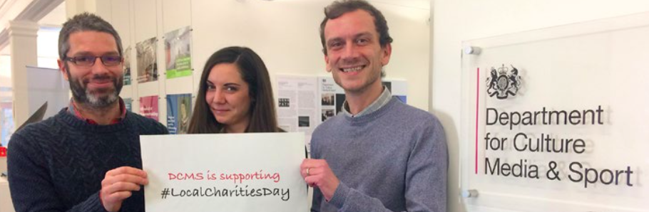

Example 1
[Name of Charity] is supporting #LocalCharitiesDay because [individual message]

Example 2
[Name of Charity] helps people to...[individual message] #LocalCharitiesDay

The supporters
Does your charity have celebrity, corporate or VIP support? If so please let us know so we can work with you to promote their support and maximise the reach. Get in touch with yasmin.kaye@culture.gov.uk and lucy.jenkinson@culture.gov.uk

The Assets
We’ve prepared these digital assets that you can download for use on your own websites and social media feeds. We’ll be adding more in the run up to the big day. Any problems? Need a hand with anything? We are here to help, contact us.

Twibbon image:
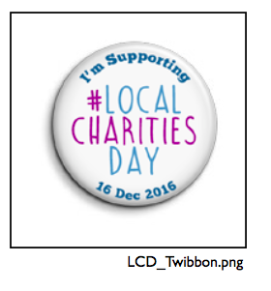

How the Twibbon could be displayed on your Twitter and Facebook profile images
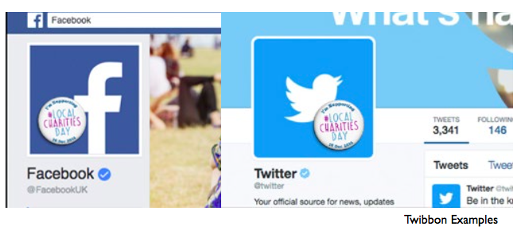

Standalone #LocalCharitiesDay graphic for Facebook and Twitter
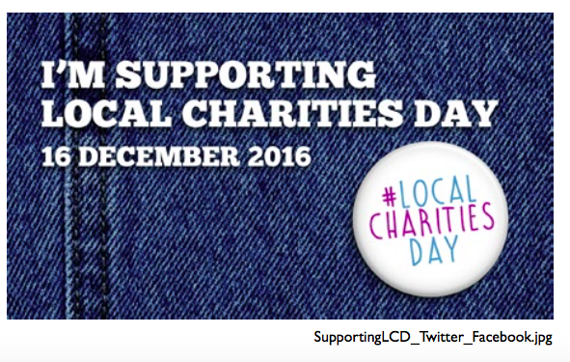

Standalone #LocalCharitiesDay graphic for Instagram
